Thermodynamics 2 Tutorial
Dry and Atmospheric Air : Specific and Relative Humidity
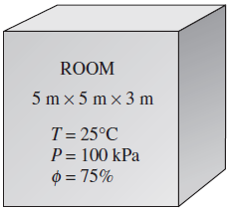
Ex: 14.1 A 5-m x 5-m x 3-m room shown in Fig. 14–7 contains air at 25°C and 100 kPa at a relative humidity of 75 percent. Determine (a) the partial pressure of dry air, (b) the specific humidity, (c) the enthalpy per unit mass of the dry air, and (d ) the masses of the dry air and water vapor in the room.

1. A tank contains 21 kg of dry air and 0.3 kg of water vapor at 30°C and 100 kPa total pressure. Determine
(a) the specific humidity,
(b) the relative humidity,
(c) the enthalpy per unit mass of dry air, and
(d) the volume of the tank.

2. A room contains air at 20°C and 98 kPa at a relative humidity of 85 percent. Determine
(a) the partial pressure of dry air,
(b) the specific humidity of the air, and
(c) the enthalpy per unit mass of dry air.

3. Determine the masses of dry air and the water vapor contained in a 240-m3 room at 98 kPa, 23°C, and 50 percent relative humidity.

