Quantitative Analysis
Using Spreadsheets
Student Guide
Thomas Vulsma
thomvu@kku.ac.th

Contents
Using spreadsheets 2
Formatting 2
Formulas and Functions 7
Commonly used functions in Excel 12
Autofill 15
Working with logical functions 18
Date Functions 22
Financial Functions 22
Applied Exercise 24

Using spreadsheets

Formatting
Learning objectives:
- Formatting text, numbers and dates
- Changing background
- Entering formulas
- Applying conditional formatting
- Hiding rows and columns
- Using headers and footers

Changing font type, colors and size in the font section of the ribbon
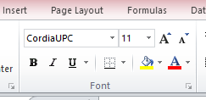
Change the background of your spreadsheet
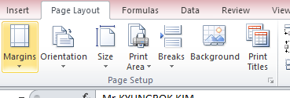

Formatting data
Calculating totals
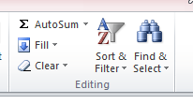

Entering formulas
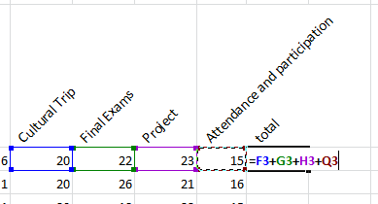
Or
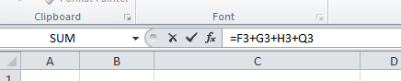
Changing number formats
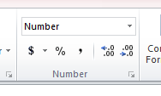

Formatting cells
Alignment
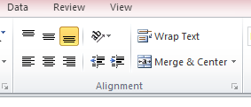
Adding borders
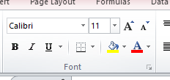
Format dialogue box
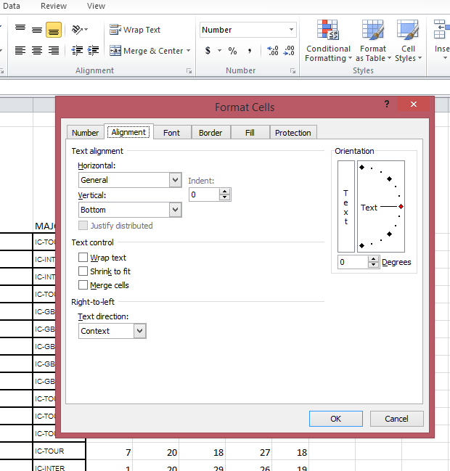

Format painter
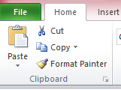
Or
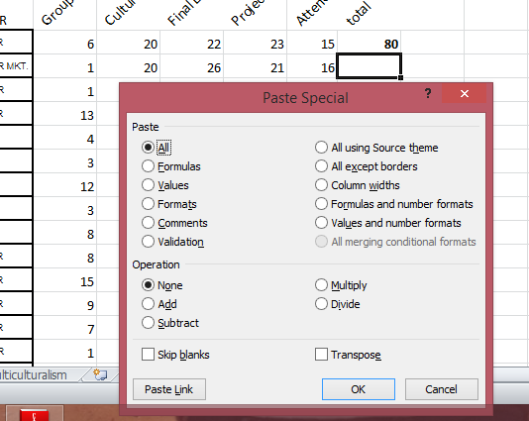
Applying styles
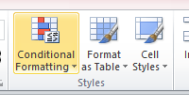
Conditional formatting

Adding data bars
Highlighting cells
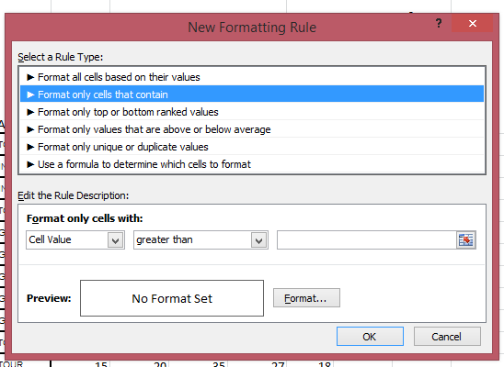
Hiding and unhiding data
Formatting for printing
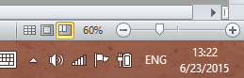
Print titles
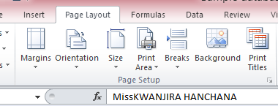
Headers and footers
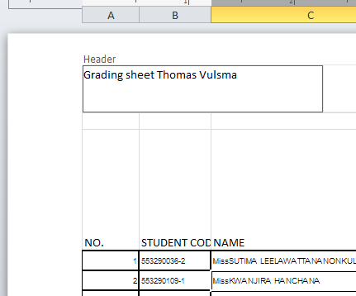

Formulas and Functions
Learning objectives:
- Copying formulas
- Building formulas with relative, absolute and mixed references
- Reviewing function syntax
- Inserting a function with the insert function dialog box
- Search for a function
- Type a function directly into a cell
- Using AutoFill in a formula and complete a series
- Entering IF logical functions
- Insert the date with the TODAY function
- Calculate payments with the PMT financial function
Entering a value in a cell taken from another cell
G3 is the reference
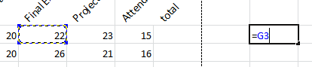
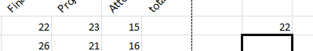
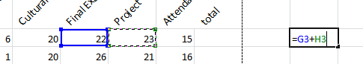
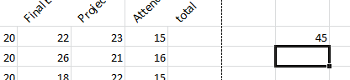

Copying a formula
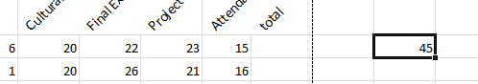
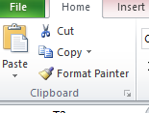
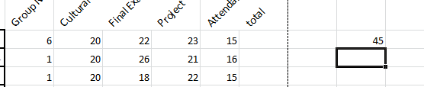
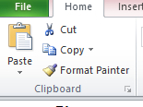
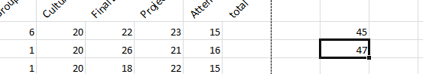
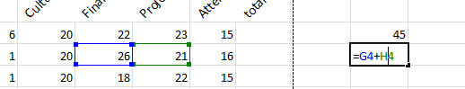

The formula changes by shifting down one row. The column stays the same.
Relative References
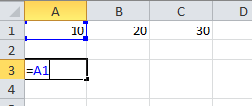
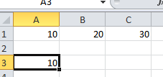

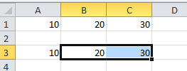
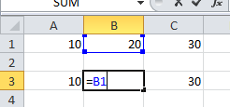
Because the cell with the formula moves to the right, the reference cell will move to the right This is called a relative reference (position of one cell to the other is relative).
Absolute References
If we want the reference cell to stay the same, we need to lock the reference cell in the formla.
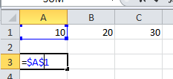
The dollar sign before the column locks the column (does not move to the right) and the dollar sign before the row locks the row (does not move down).
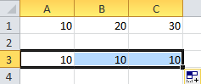
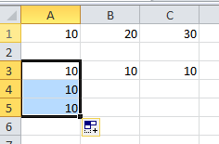
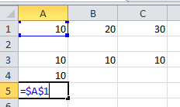
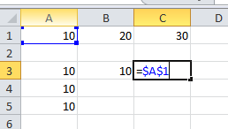
The reference cell now stays the same wherever we copy the formula to. This is called an absolute reference.
Mixed Reference
Sometimes we want to lock only the column or only the row. Then we use a mixed reference.
Locking the row
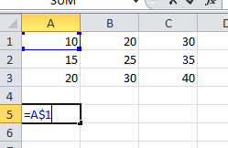
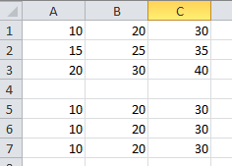
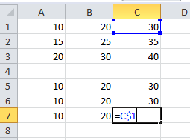
Locking the column
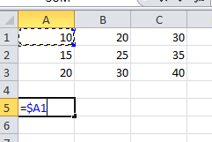
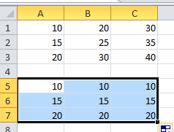
Instead of typing the $ sign you can use the F4 button.

Commonly used functions in Excel
=AVERAGE(number1, number2, number n,…)
=COUNT(value1, value2, value n,…)
=MAX(number1, number2, number n,…)
=MIN(number1, number2, number n,…)
=SUM((number1, number2, number n,…)
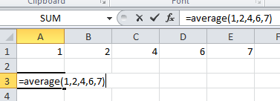
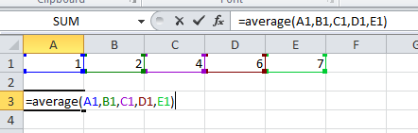
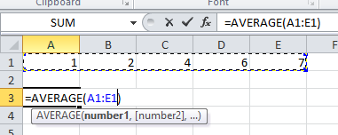
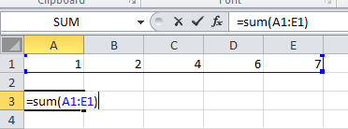
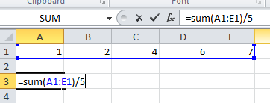
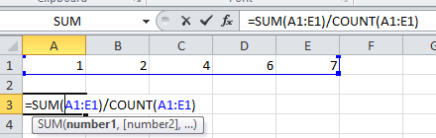
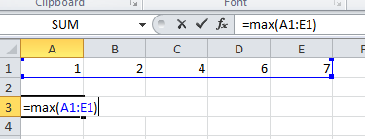

Insert a function
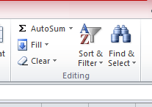
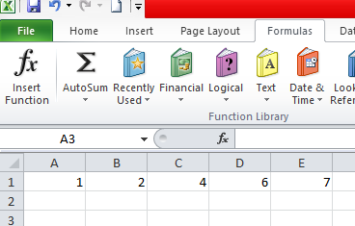
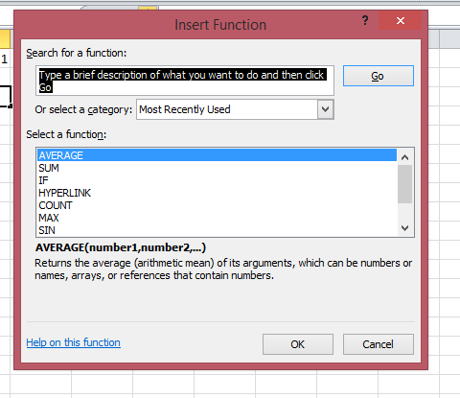
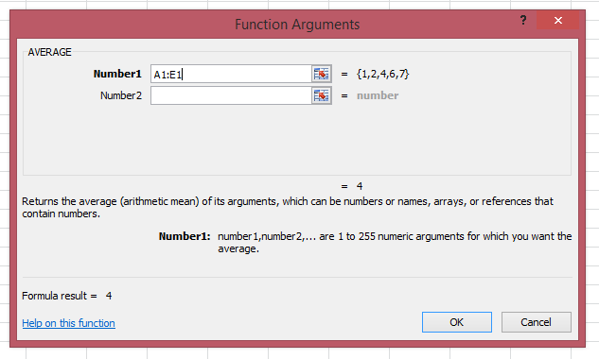

Quiz:
- What is the absolute cell reference for cell B21? What are the two mixed references?
- Cell B10 contains the formula =B1+B2. What is the formula if this is copied and pasted into the cell C20?
- Cell B10 contains the formula =$B1+$B2. What is the formula if this is copied and pasted into the cell C20?
- Cell B10 contains the formula =AVERAGE($A1:$A5). What is the formula if this is copied and pasted into cell C20?
- What formula should you enter to add (+) all numbers in the range B1:B10?
- A range is the highest number minus (-) the lowest number. What formula do you use to calculate the range of values in B1:B10?

Autofill
You can let Excel copy and paste formulas in a range of cells by dragging the fill handle
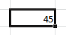
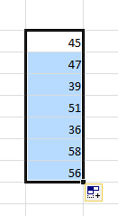

Filling a series
You can use the fill handle to let Excel fill in a series of things (numbers, dates, months, years, text)
You enter a few numbers (3) to establish a pattern
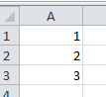
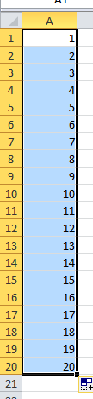
And let Excel fill in the rest
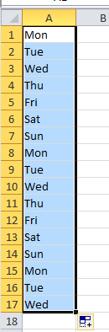
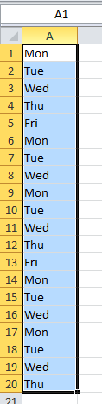

Working with logical functions
Logical functions uses values which are true or false. For example: the value in cell B5 equals 7. This can be true or false. Or: The number in cell h55 is higher than 80. This can also be true or false. You can let excel do one thing if the statement is true and something else if the statement is false.
IF functions
=IF(logical test, value if true, value if false)
Example:
=IF(A1=5, “yes”, “no”)
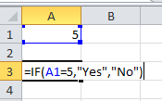
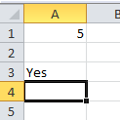
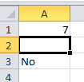
Operators
=
>
<
>=
<=
<>
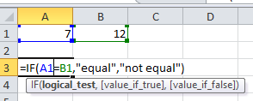
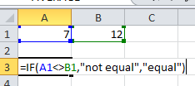
You can also let Excel give a value from another cell of true and false.
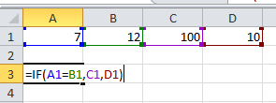
You can also have logical tests with text
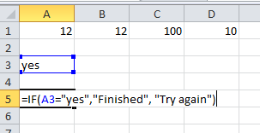
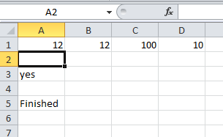
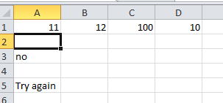

Insert an IF function
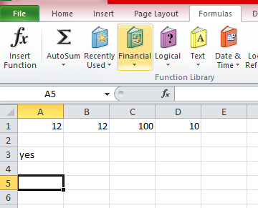
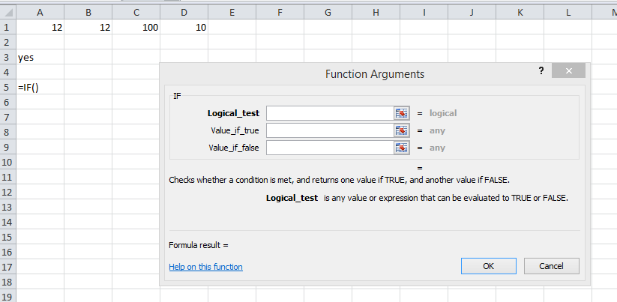
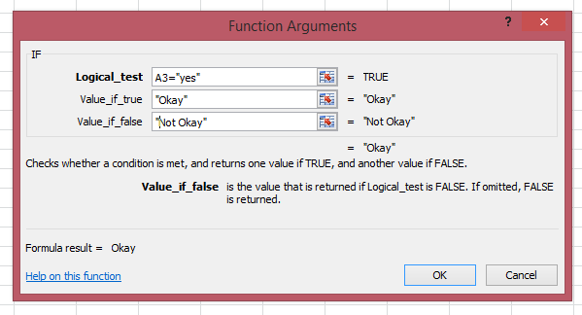
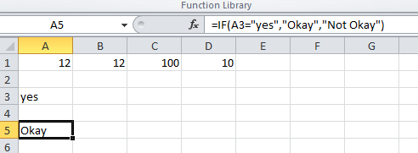

Date Functions
Very often you want to use dates to calculate something. For example, you have to pay your bill 30 days after you receive it. If you enter the date you receive the bill, excel can calculate when you have to pay it.
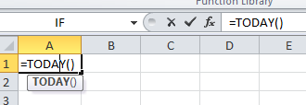
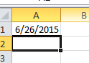
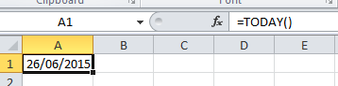
Sometimes you want to know what day of the week a date is without looking on the calendar.
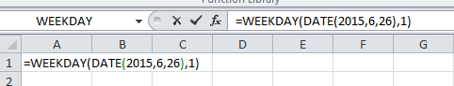
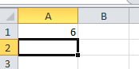

Financial Functions
If you have to make complicated calculations with financial products (like a loan), you can use the financial functions.
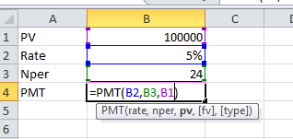
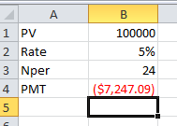
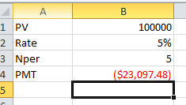
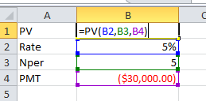
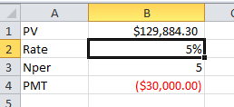

Quiz:
- If the value in cell A3 is larger than the value of A4, you want to display the word “OK”; if it is not, “RETRY”. What formula do you enter?
- What formula do you use to enter the current date?
- If you enter the values 3, 6 and 9 and you use the fill handle, what are the next 3 values?
- If you enter Mon in one cell and use the fill handle, what will display in the next 5 cells?

Applied Exercise:
Open the list of grades (sample workbook). Use Excel to calculate the final score and letter grade (A, B, C, D, F). Also, let excel indicate which students pass or failed the course.

