Spa Water

Spa water quality

Task 1 – Pre-Reading Activity

Given below is the pH scale , some examples are provided and some are left blank for you to fill. Choose the substances that may match the pH scale and write them in the correct box.
acid rain , drain cleaner , sea water, ammonia solution, lemon juice

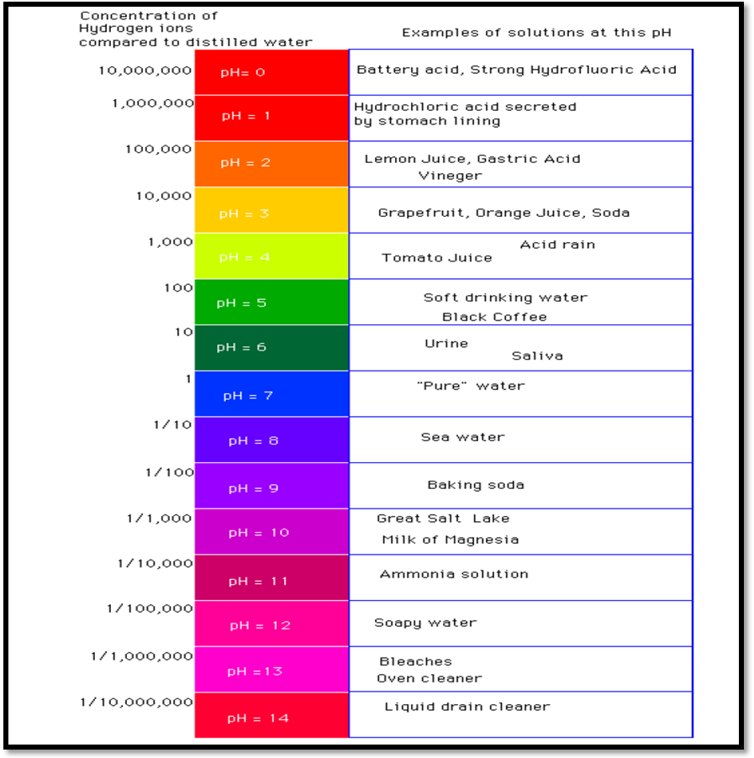

Task 2 – Reading Activity

Spa water Quality


Spa water quality is maintained through a filter to ensure cleanliness and clarity. Wastes such as perspiration, hairspray, and lotions which cannot be removed by the spa filter can be controlled by shock treatment or super chlorination every other week. Although the filter traps most of the solid material to control bacteria and algae and to oxidize any organic material , the addition of disinfectants such as bromine or chlorine is necessary.

As all water solutions have a pH which controls corrosion, proper pH balance is also necessary. A pH measurement determines if the water is acid or alkaline. Based on a 14 –point scale , a pH reading of 7.0 is considered neutral while a lower reading is considered acidic , and a higher reading indicates alkalinity or basic. All soluble bases are alkaline. High pH above 7.6 reduces sanitizer efficiency, clouds water and promotes scale formation on surfaces and equipment and interferes with filter operation. When the pH is high add a pH decreaser such as sodium bisulphate (eg. spa down). Low pH below 7.2 is equally damaging causing equipment corrosion and water which is irritating. To increase pH add sodium bicarbonate ( eg.spa up)



The recommended operating temperature of a spa is 37ºC -40ºC and is a fertile environment for the growth of bacteria and virus . This growth can be prevented by monitoring appropriate sanitizer levels or by maintaining an appropriate bromine of 3 -5 parts per million (ppm) or a chlorine level of 1-2 ppm. Liquid chlorine is too harsh for a spa and should be used in granular form.

Key Vocabulary
pH | acid | alkaline | pH balance

Questions:

- Choose the correct answer for each of the following based on the reading passage.

- The primary purpose of the passage is to -
- Relate spa maintenance to the enjoyment of a spa experience
- Explain the importance of proper spa maintenance
- Convey that spa maintenance is expensive and time consuming

- Of the chemical and temperature conditions of a spa, the condition most dangerous to one’s health is
- Cloudy and dirty water
- Bromine levels between 3 -5 ppm
- pH lower than 7.2

- Which chemical should one avoid while maintaining a spa
- Sodium bisulphate
- Sodium bicarbonate
- Liquid chlorine

- The spa filter is used to
- Maintain clear spa water
- Trap most of the solid material
- Control the level of sanitation

- Although proper chemical and temperature maintenance of spa water is necessary, the most important condition to monitor is
- Preventing equipment corrosion
- Preventing growth of bacteria and virus
- Preventing scale formation

- Answer the following questions :
- What would happen if proper pH balance of the spa water is not maintained ?
____________________________________________________________________________________________________________________________________________________________________________________________________________________________________________________________________________________________________________________________________________________

- What chemicals may be added to increase and decrease the pH of spa water?
________________________________________________________________________________________________________________________________________
________________________________________________________________________________

- How can the growth of bacteria and virus be prevented in a spa?
________________________________________________________________________________________________________________________________________
________________________________________________________________________________

- What is the meaning of spa up and spa down?
________________________________________________________________________________________________________________________________________
________________________________________________________________________________

- Read each of the following statement and write if they are TRUE or FALSE.

- A pH measurement is necessary to determine if a solution is acidic or alkaline . ______________________________________________________________

- The recommended operating temperature of a spa is 37ºC -40ºC. ____________

- To increase the pH of a spa Sodium bisulphite is added. ________________

- Chlorine added to the spa must be used in Liquid form. ________________

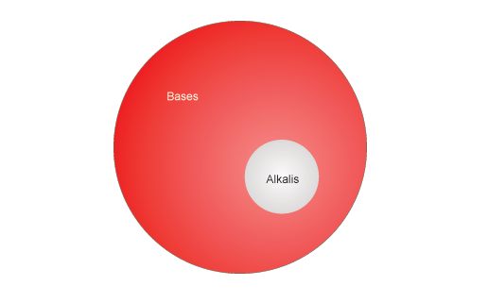
- Look at the given illustration and choose by placing a tick in the box which statement explains the correct relation between bases and alkalis?

- All bases are alkalis , but only alkalis are soluble
- All alkalis are bases, but only soluble bases are alkalis

Task 3 – Post Reading Activity
Mention 2 difficulties faced in maintaining the spa water quality.
