เลขที่......... Section.…รหัส...................….... ชื่อ-สกุล.........................................................................................................
ข้อ | 1 | 2 | 3 | 4 | รวม | ผู้ตรวจ
เต็ม | 5 | 10 | 10 | 15 | 40
คะแนน
1) Consider a thermal energy reservoir at 1500 K that can supply heat at a rate of 150,000 kJ/h. Determine the exergy of this supplied energy, assuming an environmental temperature of 25°C. (5 marks)

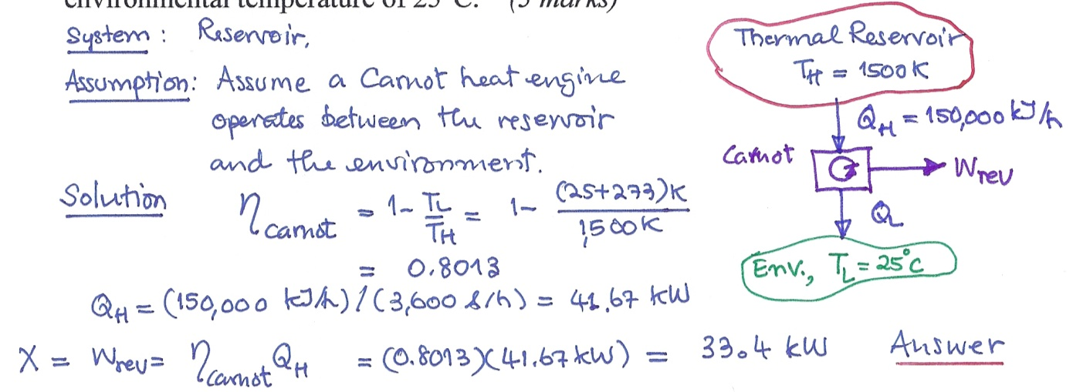

เลขที่......... Section.…รหัส...................….... ชื่อ-สกุล.........................................................................................................
2) A piston-cylinder device initially contains 200 L of air at 600 kPa and 150°C. Assuming the surroundings are at 100 kPa and 25°C, and use specific heat at 300 K, determine the availability of the air. (10 marks)
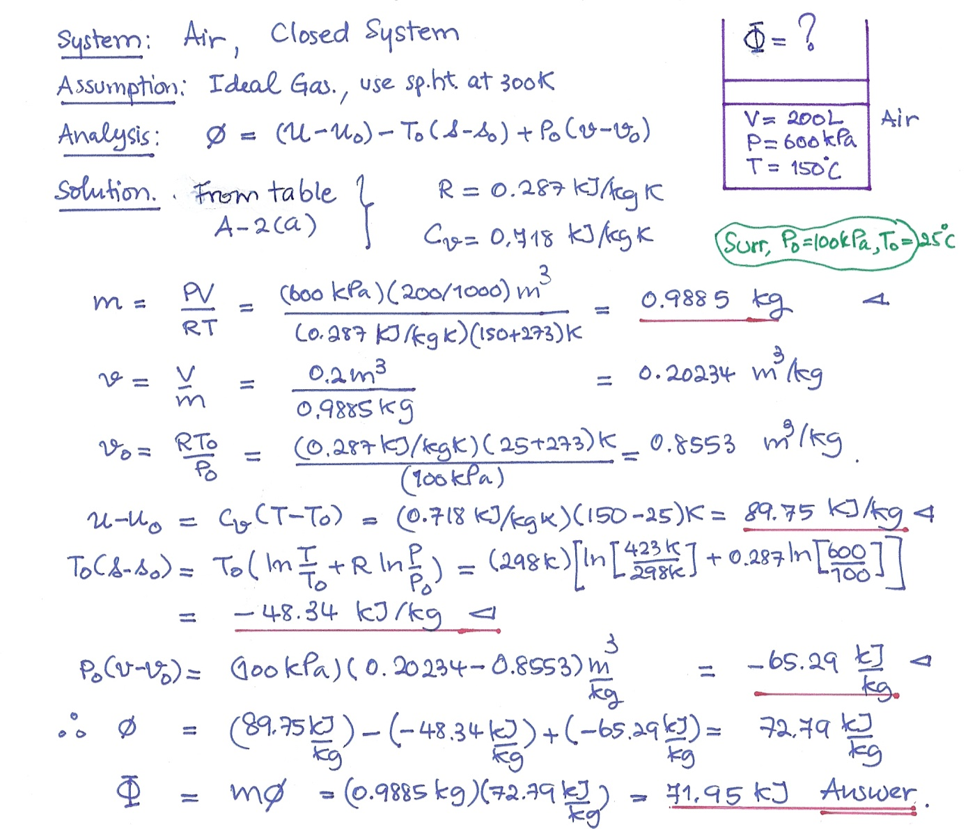

เลขที่......... Section.…รหัส...................….... ชื่อ-สกุล.........................................................................................................
3) A gas mixture consists of 8 kg of 0₂, and 22 kg of CO₂, Determine (a) the mass fraction of each component, (b) the mole fraction of each component, and (c) the average molar mass and gas constant of the mixture. (10 marks)
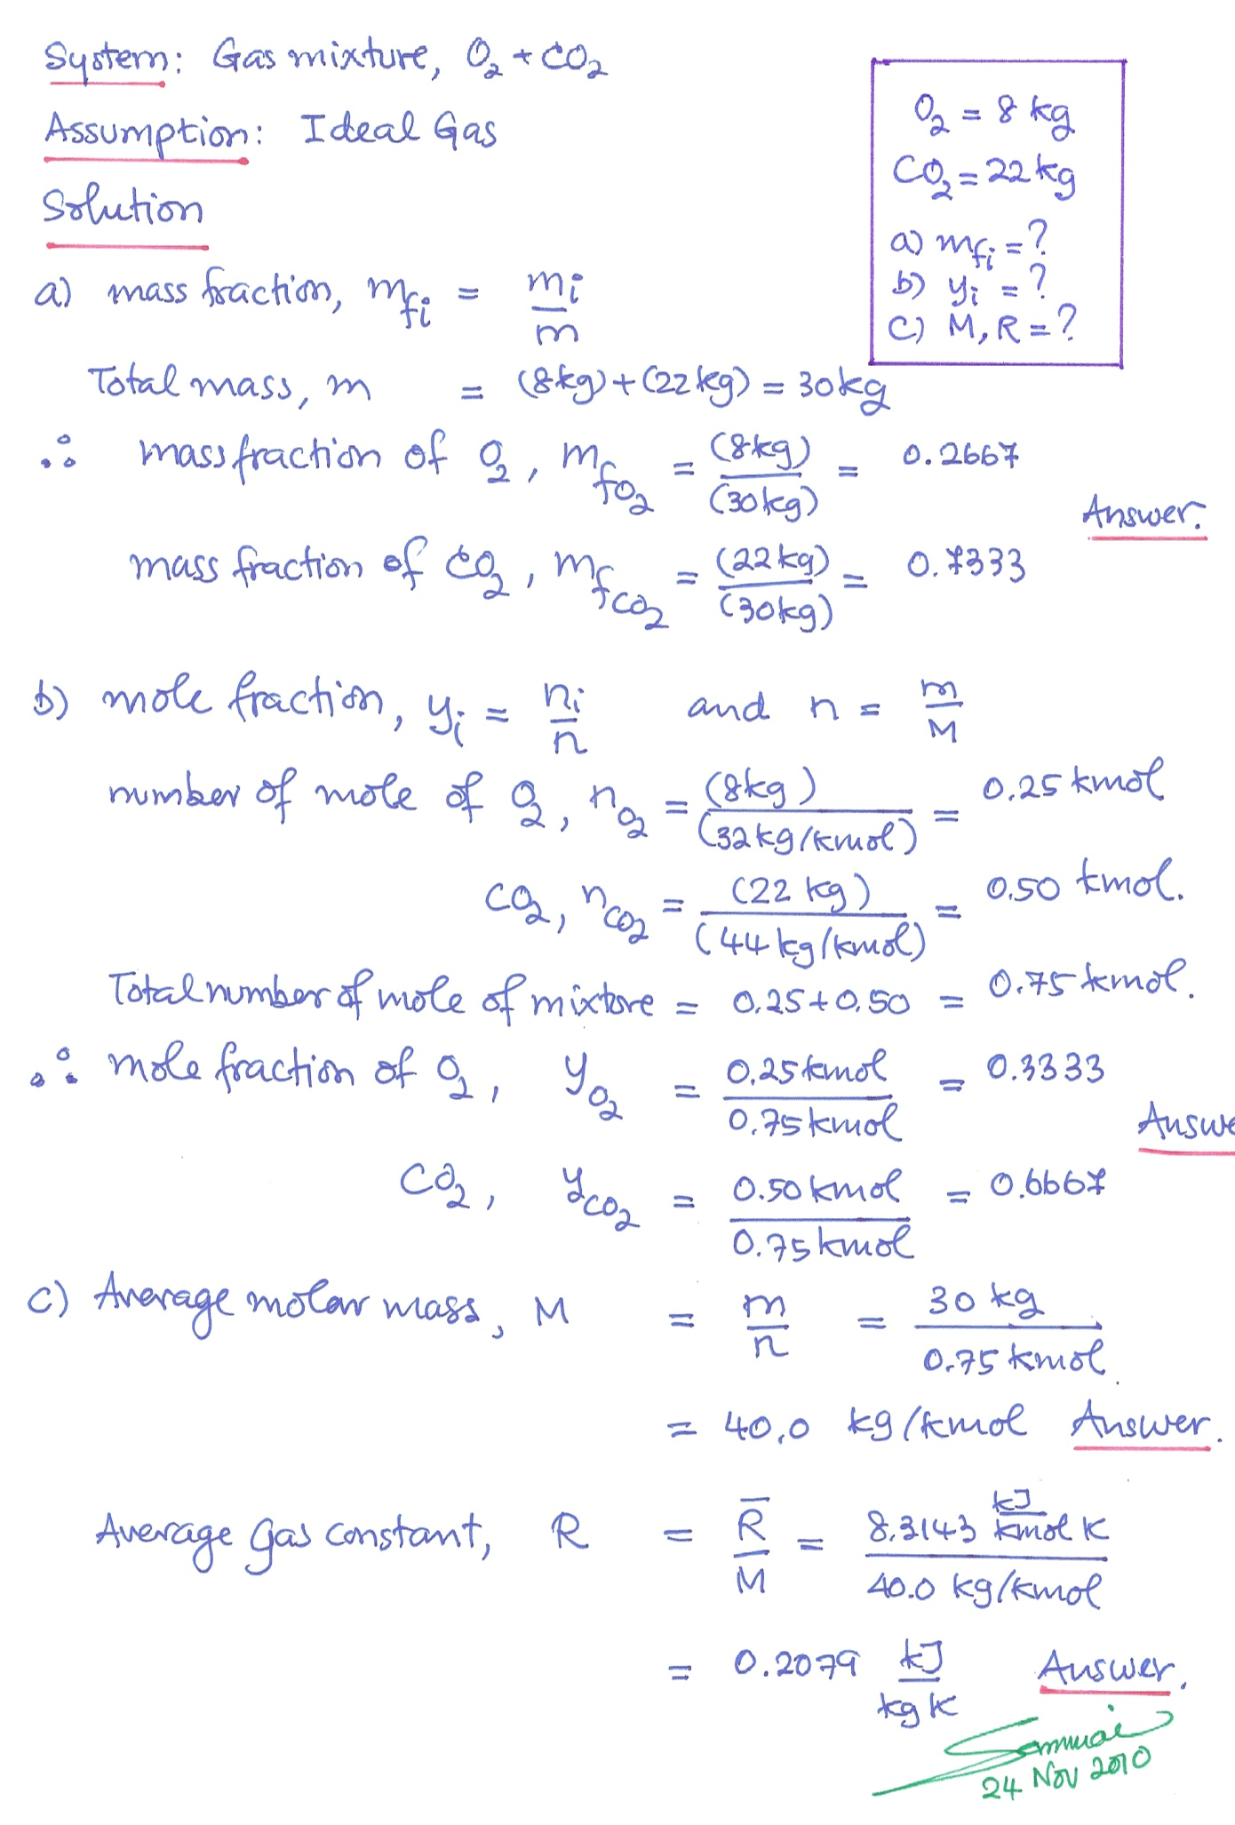

เลขที่......... Section.…รหัส...................….... ชื่อ-สกุล.........................................................................................................
4) Ethane (C₂H₆) at 20°C and 200 kPa and methane (CH₄) at 45°C and 200 kPa enter an adiabatic mixing chamber. The mass flow rate of ethane is 9 kg/s, which is twice the mass flow rate of methane. Determine (a) the mixture temperature and (b) the partial pressure of each gas in the mixture. (15 marks)

System: Gas Mixture : CV mixing Chamber
Assumptions: Ideal gas, Constant Cp at 300K
SSSF process, neglect KE, PE, Adiabatic --> Qcv =0
Analysis: (a) 1st law: and using Dalton’s Law:
Q_{cv} + Σm₁h₁ = W_{cv} + Σm₂h₂
Q_{cv} =0 and = W_{cv}=0; Σ(mh₁)_{i} - Σ(mh₂)_{i} = 0 Σm _{i}(h₂-h₁)_{i} = 0
(b) P_{i}/P = n_{i}/n
Solution:
(a) 1st law: and using Dalton’s Law:
Σm _{i}(h₂-h₁)_{i} = 0 or Σm _{i}Cp_{i}(T₂-T₁)_{i} = 0 then Σm _{i}Cp_{i}T₂- Σm _{i}Cp_{i}T_{1i} = 0
Because T₂ are the same for all gas, then
T₂Σm _{i}Cp_{i} - Σm _{i}Cp_{i}T_{1i} = 0 , therefore T₂ = (Σm _{i}Cp_{i}T_{1i} )/(Σm _{i}Cp_{i} )

Therefore: T₂ = (7,882.5 kJ)/(26.0 kJ/K) = 302.7K = 29.7 ºC Answer

(b) At mixing condition: P_{i}/P = n_{i}/n and n = m/M
and the mixture pressure, P₂ = P₁= 200 kPa

Partial pressure of C₂H₆ = 128 kPa
Partial pressure of CH₄ = 72 kPa Answer

