Thermodynamics II Test no.2 Saturday 18 December 2010 Time 10:00-11:30
ข้อ
คะแนน
1

2

รวม

5

4

3

ผู้ตวรจ

เลขที่…...Section…...ID………………….Name………….…..……………………
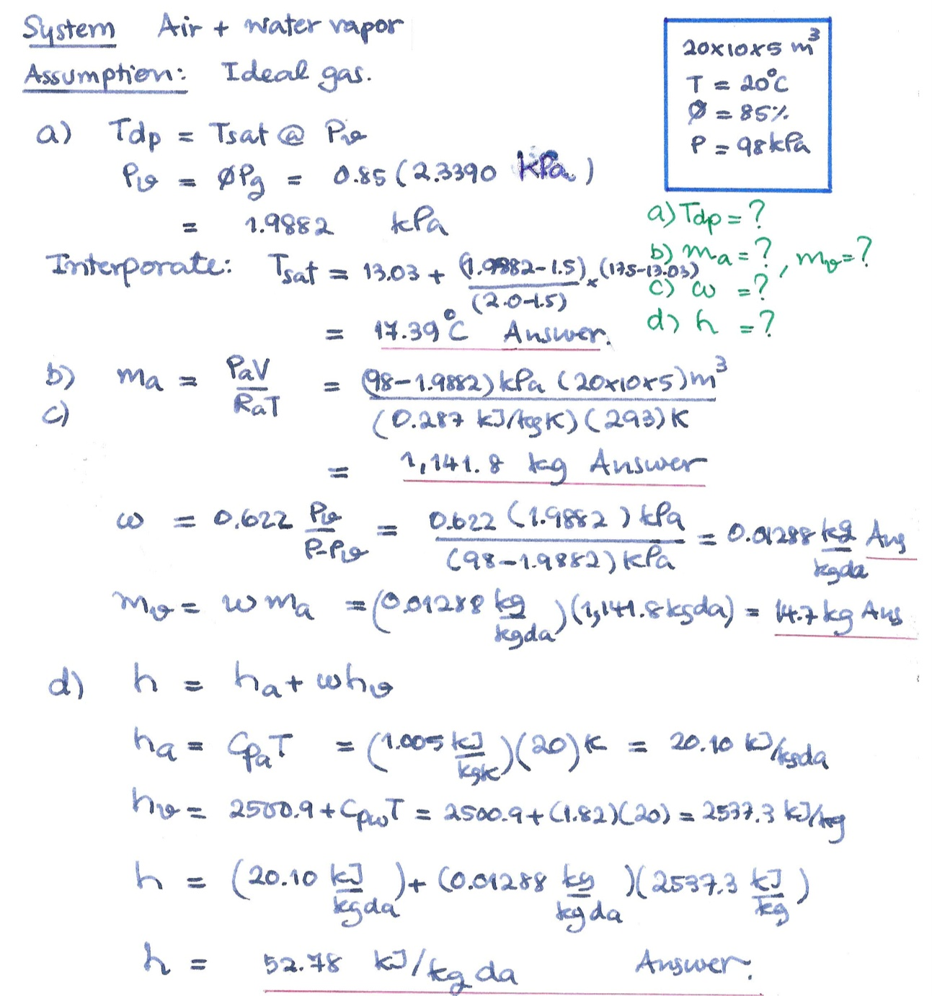
1. A 20x10x5 m³ room contains air at 20°C and 98 kPa at a relative humidity of 85 percent. Calculate (a) the dew point of the air, (b) the mass of water and the mass of dry air, (c) the specific humidity of the air, and (d) the enthalpy per unit mass of dry air. (5 Marks)
@=1
1
1
1
1
1
1

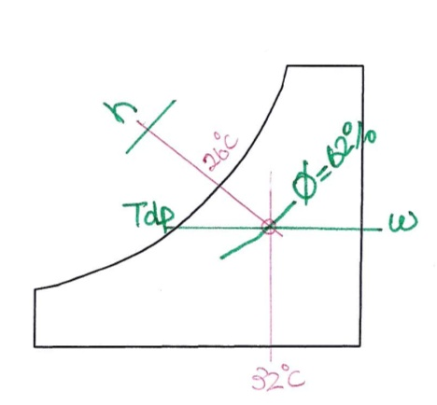
2) The air in a room at a pressure of 1 atm, has a dry-bulb temperature of 32°C, and a wet-bulb temperature of 26°C. Using the psychrometric chart, determine (a) the specific humidity, (b) the enthalpy (in kJ/kg dry air), (c) the relative humidity, (d) the dew-point temperature. ( 5 Marks)

Answer | Value | Unit
(a) the specific humidity | 0.019 | kg/kg da.
(b) the enthalpy | 80.9 | kg/kg da.
(c) the relative humidity | 62 | %
(d) the dew-point temperature | 24 | ºC

Thermodynamics II Test no.2 Saturday 18 December 2010 Time 10:00-11:30
เลขที่…...Section…...ID………………….Name………….…..……………………
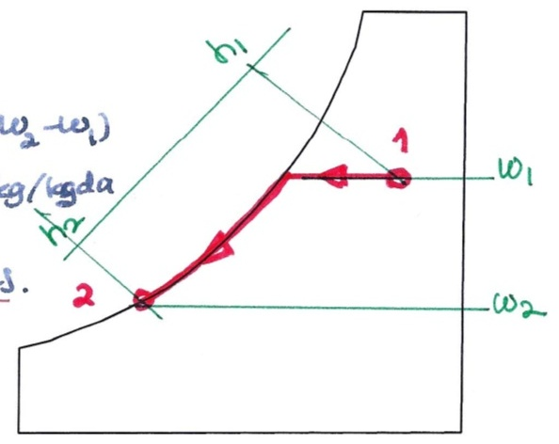
3) The air in problem 2) was cooled by a cooling coil to 15ºC. Show the process occurred. Write the analysis and using Psychrometric chart to determine, (a) the amount of moisture removed per kg dry air, and (b) the amount of heat removed per kg dry air. (10 marks)
2
2
1
ระบบ-ระเบียบ-สะอาด- 2
2
1

(b) Water mass balance
m_{v1} + m_{w, add} = m_{v2}
m_{w, add} = m_{v2} - m_{v1}
m_{w, add} = m_{a} (w₂ - w₁) ………..(1)
from Psychrometric chart:
w₁ = 0.019 and w₂ = 0.0107 kg/kg da
therefore, m_{w, add} = (1 kg da.)*( 0.0107- 0.019) kg/kg da
= -0.0083 kg
The water removed is 0.0083 kg/kg da Answer

(b) CV. Cooling coil: 1st Law, SSSF neglect ΔKE ΔPE and W = 0
q + h₁ = h₂
q = h₂ - h₁…………………….(2)

from Psychrometric chart:
h₁ = 80.9 and h₂ = 42.0 kJ/kg da
therefore, q = (42.0 – 80.9) kJ/kg da
= -38.9 kJ/kg da.
The heat removed is 38.9 kJ/kg da. Answer

Thermodynamics II Test no.2 Saturday 18 December 2010 Time 10:00-11:30
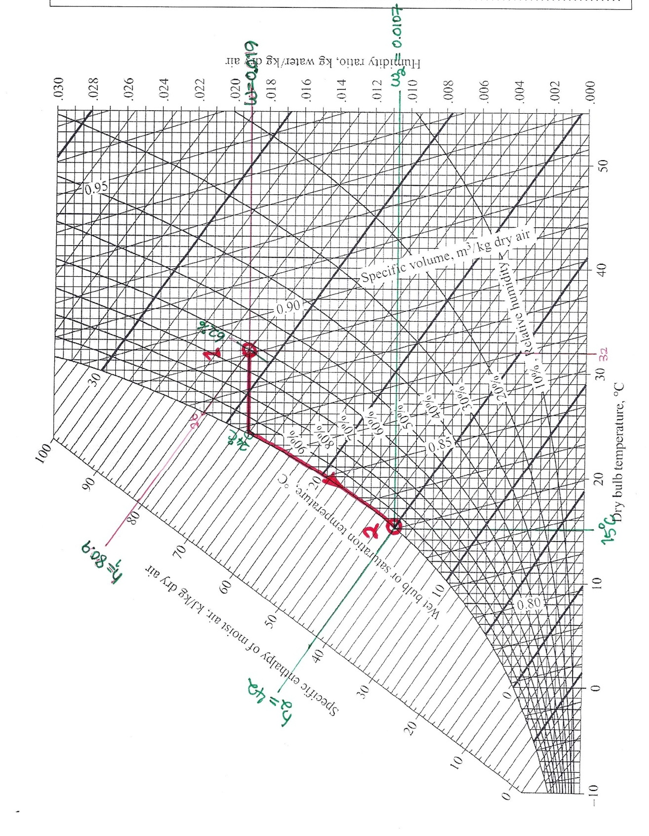
เลขที่…...Section…...ID………………….Name………….…..……………………

Thermodynamics II Test no.2 Saturday 18 December 2010 Time 10:00-11:30
เลขที่…...Section…...ID………………….Name………….…..……………………
4) Two airstreams are mixed steadily and adiabatically. The first stream enters at 35°C and 40 percent relative humidity at a rate of 20 kg/min, while the second stream enters at 10°C and 90 percent relative humidity at a rate of 5 kg/min. Assuming that the mixing process occurs at a pressure of 100 kPa. Show the process on a psychromatic chart. Write the analysis, including the detail of how each variable is to be determine, in order to determine (a) the specific humidity, (b) the dry-bulb temperature of the mixture. (10 marks)
10 ºC, 90 %RH, 5 kg/min

35 ºC, 40 %RH, 20 kg/min

1
3
2
- w₃ = ?
- T_{db3}=?

Φ₁
T_{db1}
Φ₂
T_{db2}
Φ₃
T_{db3}
1
2
ระบบ-ระเบียบ-สะอาด- 1
2
1
1
1
1

Thermodynamics II Test no.2 Saturday 18 December 2010 Time 10:00-11:30
เลขที่…...Section…...ID………………….Name………….…..……………………

5) A wet cooling tower is to cool 25 kg/s of cooling water from 40 °C to 30°C at a location where the atmospheric pressure is 96 kPa. Atmospheric air enters the tower at 20°C, and 70 percent relative humidity and leaves saturated at 35°C. Make up water is available at 20°C. Neglecting the power input to the fan. Write the analysis, including the detail of how each variable is to be determine, in order to determine (a) the volume flow rate of air into the cooling tower and (b) the mass flow rate of the required makeup water. (10 marks)
Warm water in
Cold water out
Air out
Air in
Make up water
3
5
1
2
4
2
2
1
ระบบ-ระเบียบ-สะอาด- 1
2
1
1

