Readworks.com (Audio record 6:03 minutes)
https://www.readworks.org/article/Reading-Rock-Strata/03f5deb9-5de6-423a-b478-70daf0e3aef1#!articleTab:content/

Reading Rock Strata
1
Earth is about 4.5 billion years old! With that many eons of history, how can scientists learn about what has happened on our planet’s surface over time? One key way geologists understand and date events in Earth’s history is by studying rock strata and other rock formations. Rock strata are layers of rock that have been deposited over time.

Nicolas Steno, a 17th-century Danish geologist, was one of the first geologists to realize Earth’s crust contains a chronological history of geologic events. He thought of certain principles that helped geologists make sense of the rocks they were studying. Today, four of his principles govern many aspects of this field. These are the principles of original horizontality, lateral continuity, superposition, and cross-cutting relationships. Although there are more geological principles outside of Steno’s research, these four are some of the most important. Today, geologists correct and expand upon these principles, while still applying them to make sense of Earth’s vast history.

Principle of Original Horizontality
2
The principle of original horizontality states that layers of sediment follow the law of gravity and are originally deposited horizontally. Rocks remain horizontal until a force acts on them, pushing or pulling them out of their horizontal orientation. Steno believed that strongly tilted rocks were not always tilted. Instead, they were forced off-kilter by catastrophic events like volcanic eruptions or the collapse of caves.

Today, geologists know that coarser-grained sediments, like sand, can be deposited at a slight angle. If you take a look at a sand dune, you can see that the sand has not been deposited horizontally. Even though geologists now know that Steno’s principle does not apply in all cases, they can still use it to analyze how rock strata have been disturbed over time. For example, geologists know that if they come across folded or tilted rock strata, those layers were once closer to horizontal. They likely became folded or tilted as a result of tectonic plate collisions.

Principle of Lateral Continuity
3
The principle of lateral continuity states that all rock layers extend sideways in all directions. That means that even if identical or similar rock layers are separated today, the rock layers were likely continuous in the past. These rock layers may have become separated due to erosion or other forces. For instance, identical rock layers on opposite sides of a river were once connected. The water from the river slowly eroded these rocks, separating them. Rock layers can also be separated as a result of tectonic plate movement. Faults, or cracks in the earth’s crust, cause rock layers to move and separate. Scientists use the principle of lateral continuity to help determine where and how continents were once connected.

Principle of Superposition
4
The principle of superposition states that layers of rock are laid down on top of one another. The oldest rock layer is on the bottom and the youngest is on top. Paleontologists use this principle when digging through layers of sedimentary rock to find fossils. By noting the strata in which a fossil is found, they are able to relatively date it. If they find one fossil in a much deeper layer than another fossil, they can often infer that the first fossil is older. This dating technique also works the other way around: fossils can help scientists determine the relative ages of sedimentary rocks! Paleontologists know which fossils are associated with particular time periods. The order in which certain types of fossils appear and disappear in rock layers gives information about the relative ages of the rock layers.
5
The principle of superposition does not mean that scientists can always easily figure out the relative ages of rock layers. Rock strata often become deformed or changed in ways that complicate this principle. For example, erosion can remove large portions of rock, making it unclear whether or not a layer of rock is the original top layer. The collapse of a cave may also transport large pieces of an upper rock layer downwards. Volcanic eruptions can also distort rock formations. Lava can flow through cracks in surrounding rocks and squeeze between older rock layers. When lava cools, it forms igneous rock. In this way, volcanic eruptions can change landforms and transform environments. For this reason, scientists only apply the principle of superposition to sedimentary rock, not igneous rock.

Principle of Cross-Cutting Relationships
6
The principle of cross-cutting relationships states that any geological structure that cuts through another structure must be younger than the structure it disrupted. This makes sense because for one rock to get cut through by lava or another rock, it had to exist first! By examining which rock strata are cut by intrusions and applying this law, geologists can learn which of the rocks are older or younger.

For example, take a look at the picture below. Spot the light-gray, white, and black rock. The thin black rock is whole, so it is the youngest. The white rock is the second youngest because it is cut by the black rock. The light-gray rock is the oldest because it is cross-cut by both the white and black rock.

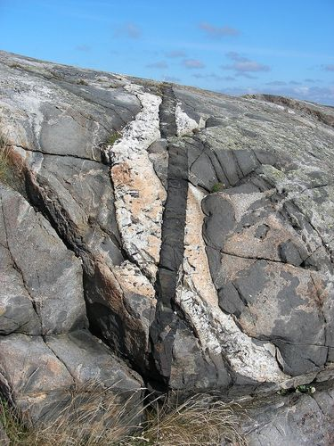
Igneous rock showing the Law of Cross-Cutting
Thomas Eliasson of Geological Survey of Sweden, CC BY 2.0

