Thesis progression
Thesis title: Bacteriophage-vancomycin combination against vancomycin-intermediate
Staphylococcus aureus

Thesis progression title: The effect of phage and vancomycin combination against S. aureus in vitro

Student: Kansuda Suksaman Student ID: 675070022-5
Advisor: Asst. Prof. Dr. Umaporn Yordpratum
Co-advisor: Dr. Pratsanee Hiangraj
Date: March 11, 2026

1. Introduction
Staphylococcus aureus is a Gram-positive coccus and a common antibiotic-resistant bacterial infection that is prevalent in hospital environments (Vestergaard et al., 2019). This organism causes skin and soft tissue infection, osteomyelitis, endocarditis, pneumonia, and bacteremia (Alghizzi & Shami, 2023). S. aureus has become resistant to numerous antibiotics for more than 20 years. Beta-lactams have been key antibiotics for treating S. aureus infections. However, some strains carried plasmid-borne beta-lactamase genes, rendering them ineffective before penicillin was introduced. Later, the acquisition of the staphylococcal cassette chromosome mec (SCCmec) gave rise to methicillin-resistant S. aureus (MRSA) (Vestergaard et al., 2019). Vancomycin, the first discovered glycopeptide, remains a key empirical and definitive treatment option for MRSA infections (Bamigboye et al., 2018). The first vancomycin-intermediate S. aureus (VISA), with a minimum inhibitory concentration (MIC) of 8 µg/mL, was reported in Japan in 1997 (Hiramatsu et al., 1997). The global prevalence of vancomycin-resistant S. aureus (VRSA), vancomycin-intermediate S. aureus (VISA), and heterogeneous VISA (hVISA) in two periods (before 2010 and 2010-2019) shows a gradual increase (Shariati et al., 2020a). The VISA prevalence in Thailand is 0.3% (0.0-0.7%), indicating a very low prevalence of VISA in the specific Thai study cited. The hVISA prevalence is 9.7%, indicating a significantly higher prevalence of hVISA compared to VISA. The low VISA prevalence is encouraging, but the substantial prevalence of hVISA is a concern (Shariati et al., 2020a). VISA develops through mutations in cell-wall synthesis genes, and this phenotype can also develop in response to the natural stress conditions within S. aureus biofilms (Chapman et al., 2024). These infections are challenging to treat because S. aureus forms biofilms that greatly increase antibiotic resistance (Joo et al., 2023). Biofilm is a structured community of bacteria that forms multiple layers over the substrate surface through intercellular and or the membrane-like extracellular matrix (ECM) produced by forms through the adhesion of bacterial cells and the accumulation of extracellular polymeric substances (EPS) produced during growth, after adherence, biofilms allow bacterial cells to spread to the host’s uncolonized sites (Joo et al., 2023). Biofilm formation protects bacteria from both host immune defenses and antibiotic action. In synovial fluid, S. aureus can organize as floating biofilm-like aggregates, enhancing the MIC of antibiotics necessary. These aggregates provide a protective environment that reduces recognition and clearance by immune cells (Taha et al., 2023a). These biofilm-like aggregates are a key factor in treatment failure of Prosthetic joint infection (PJI) (Taha et al., 2023a). Therefore, S. aureus can be resistant to external challenges, and the treatments for biofilm infections are currently difficult (Peng et al., 2023).
Because conventional antimicrobials increasingly fail against resilient biofilms and multidrug‑resistant organisms are rising, novel anti‑biofilm strategies are urgently needed. Phage therapy is increasingly being explored as an adjunctive treatment or a viable alternative. Phage therapy is recognized as a safe, targeted alternative to antibiotics, particularly against multidrug-resistant bacteria. Preclinical and clinical studies show a safety profile that causes minimal side effects, typically limited to mild flu-like symptoms or local reactions at the administration site. (Palma & Qi, 2024)
Bacteriophages (phages) are viruses that infect bacteria specifically and replicate using the metabolic machinery of their bacterial host. In the lytic cycle, the injected genome is transcribed and replicated, resulting in the assembly of progeny phages and the eventual lysis of the host cell, thereby inhibiting bacterial growth. In the lysogenic cycle, the phage genome becomes integrated into the bacterial chromosome, remaining dormant until induced to enter the lytic cycle. (or persists as an extrachromosomal prophage). It is replicated passively with the host until induction triggers the lytic program. We focus here on lytic phages, lytic phages offer several therapeutic advantages: they can self‑amplify at the infection site and target bacteria with greater specificity than broad-spectrum antibiotics (minimizing disruption of the microbiota), generally have a low incidence of adverse effects, may be suitable for patients with antibiotic allergies, are relatively inexpensive to produce, and can be formulated for multiple routes of administration, including injection. Phages can enhance antibacterial effectiveness when used in combination with antibiotics, often producing synergistic effects. Phage–antibiotic synergy (PAS) refers to antibiotics enhancing phage activity and is not the same as bacteriophage therapy; antibiotics largely replaced the latter in the mid‑20th century but has since seen renewed research and clinical interest. As a result, the size of phage plaques significantly increases when antibiotics in phage-infected bacteria are injected (Kim et al., 2018). A promising solution to bacterial resistance is bacteriophage-antibiotic combination therapy, which can prolong or restore existing activity of antibiotics against specific bacteria (Diallo & Dublanchet, 2022), and phages can be used to deliver antibiotics directly to bacterial cells, elevating the antibiotic concentration at the infection site and reducing the risk of off-target effects (Pires et al., 2016).
The incidence of antibiotic‑resistant Staphylococcus aureus has risen significantly in recent years. Development of new antibiotics remains slow and constrained by high costs. This study aims to evaluate the efficacy of a bacteriophage–vancomycin combination against vancomycin‑intermediate S. aureus (VISA) in vitro, in both planktonic cultures and biofilms, and ex vivo using porcine skin and synovial fluid models.

2. Objectives
1. To characterize the structure and genome of phages specific to S. aureus
2. To evaluate the effect of phage and vancomycin against vancomycin intermediate S. aureus (VISA) in both planktonic cultures and biofilms
3. To evaluate the effect of phage and vancomycin against vancomycin intermediate S. aureus (VISA) in porcine skin
4. To evaluate the effect of phage and vancomycin against vancomycin-intermediate S. aureus (VISA) in synovial fluid

3. Thesis progression objectives
To evaluate the effect of phage and vancomycin against vancomycin intermediate S. aureus (VISA) in planktonic cultures

4. Materials and methods
  - Bacterial host and phage
    - Bacterial isolation
MSSA-5062 Staphylococcus aureus was obtained from the clinical microbiology laboratory of the medical in Srinagarind Hospital (Khon Kean, Thailand). MSSA and MRSA was obtained from the clinical microbiology laboratory of the medical in Srinagarind Hospital. VSSA and VISA strains was kindly provided by Asst. Prof. Auttawit Sirichoat. All 100 of S. aureus strains were stored in 20% glycerol at −80°C.
    - Bacteriophage isolations
S. aureus phage, including J, W31, and W32 were collected from a dairy farm (phage J) and wastewater (phage W31, phage W32) in an agricultural farm, Khon Kean University (Khon Kaen, Thailand). All phages were screened with the MSSA-5062 strain by spot test. The mid-log MSSA-5062 in nutrient broth was adjusted to 0.5 MacFarland with phosphate-buffered saline (PBS, pH 7.4) and flushed on nutrient agar with CaCl₂ plate. All phages were diluted with SM buffer (NaCl, MgSO₄ •7H₂O, 1 Tris-HCl pH 7.5, 1% Gelatin), then spotted the phage on an agar plate containing bacteria and incubated at 37°C for 18 hours. After incubating, the number of plaques was counted and calculated the phage titer.
4.2 Media and Reagents
- Nutrient broth (NB)
- Nutrient Agar (NA)
- Sterile phosphate-buffered saline (PBS) (for bacteria dilution) or SM buffer (for phage dilution)
- Vancomycin stock solution
- 0.22 µm syringe filter (for sterilization of phage lysate)
- 40% CaCl₂ solution (enhances phage adsorption)
- Distilled water

4.3 Equipment
- Sterile test tubes and autopipettes
- 96-well plate
- Incubator (37°C)
- Shaking incubator (200 rpm)
- Rotator Mixer
- Varioskan™ LUX Multimode Microplate Reader

4.4 Methods
4.4.1 The effect of phage and vancomycin combination against S. aureus in vitro

1) Planktonic killing activity
The planktonic killing assay was performed to evaluate the combined effect of phage and vancomycin against S. aureus in vitro. Two phages (W31 and W32) were tested against S. aureus MSSA 5-062 and VISA 17-97 strains. Each tube was inoculated with 2 mL of bacterial suspension at 10⁷ CFU/mL, followed by 2 mL of treatment with different conditions: SM buffer (control), phage alone at MOI 1 (10⁷ PFU/mL) or MOI 0.1 (10⁶ PFU/mL), vancomycin alone at ½ MIC or ¼ MIC, and phage–vancomycin combinations (MOI 1 or 0.1 with ¼ MIC or ½ MIC vancomycin). The tubes will be incubated at 37°C with shaking at 200 rpm, and bacterial growth was monitored by measuring optical density (OD₆₀₀) and counting on agar (CFU/ml) at 0, 2, 4, 8, 12, and 24 hrs.

4. Results
4.1 The effect of phage and vancomycin combination against S. aureus in vitro
1) Effect of bacteriophage and vancomycin combination against MSSA in vitro
The antibacterial activity of bacteriophages W31 and W32, alone and in combination with vancomycin, against MSSA was evaluated by measuring optical density (OD600) and viable cell counts (CFU/ml). In the untreated control, MSSA showed rapid growth with OD600 increasing from 0.0215 at 0 h to 0.6764 at 24 h, and bacterial counts increased from 1.73 × 10⁷ CFU/ml to 1.78 × 10⁹ CFU/ml. Vancomycin alone at 1 µg/ml (1/2 MIC) slightly inhibited bacterial growth during the early phase, but regrowth was observed at 24 h, with CFU increasing to approximately 10⁹ CFU/ml. A lower vancomycin concentration (0.5 µg/ml; 1/4 MIC) exhibited limited antibacterial activity and permitted substantial bacterial growth over time. Treatment with bacteriophage alone significantly reduced bacterial growth. Phage W31 and W32 at MOI 1 showed strong antibacterial activity, maintaining low OD values and reducing viable cell counts to undetectable levels by 24 h in several conditions. However, slight increases in OD values at later time points suggested possible bacterial regrowth. The combination of bacteriophage and vancomycin demonstrated enhanced antibacterial activity compared with antibiotic treatment alone. In particular, W31 or W32 combined with vancomycin (1 µg/ml) significantly reduced bacterial growth and CFU/ml throughout the incubation period. These results indicate a synergistic antibacterial effect between bacteriophages and vancomycin against MSSA.

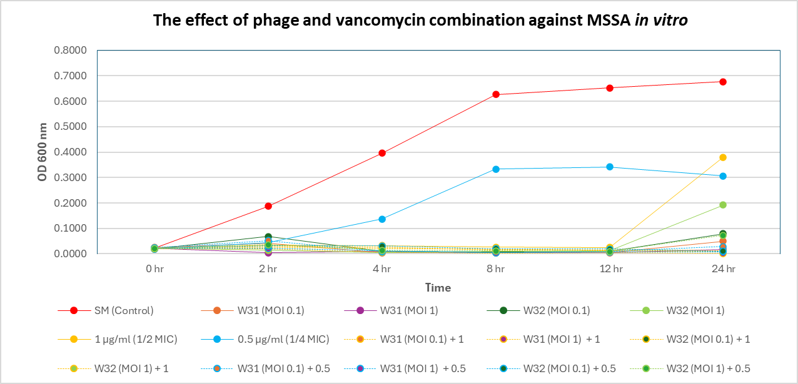
Figure 1: The effect of bacteriophage and vancomycin combination against MSSA in vitro (OD 600nm)

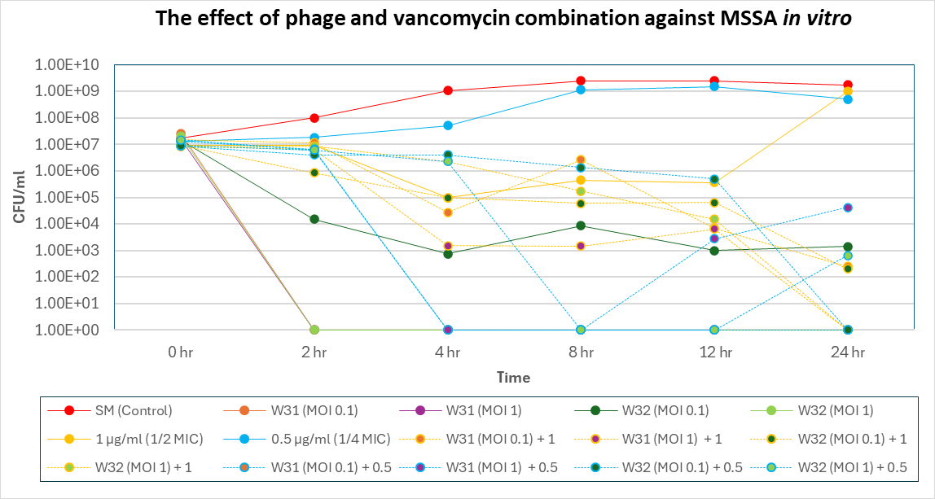
Figure 2: The effect of bacteriophage and vancomycin combination against MSSA in vitro (CFU/ml)

2) Effect of bacteriophage and vancomycin combination against VISA in vitro
The antibacterial activity of bacteriophages and vancomycin against VISA was also evaluated using OD600 and viable cell count (CFU/ml). In the untreated control, VISA exhibited robust growth, with OD600 increasing from 0.0265 to 0.4221 and CFU counts increasing from 4.83 × 10⁷ CFU/ml to 1.55 × 10⁹ CFU/ml within 24 h. Vancomycin alone at 2 µg/ml (1/2 MIC) temporarily suppressed bacterial growth during the early incubation period; however, significant regrowth was observed at 24 h, with bacterial counts reaching approximately 10⁹ CFU/ml. Similarly, treatment with 1 µg/ml (1/4 MIC) failed to effectively control bacterial proliferation. Bacteriophage treatment alone (W31 and W32) resulted in a noticeable reduction in bacterial counts during the early time points (4–8 h) with 6 log unit reduction. However, bacterial regrowth occurred at later time points, particularly at 24 h, indicating that phage monotherapy was insufficient to completely eliminate VISA. Combination therapy with bacteriophages and vancomycin improved antibacterial efficacy compared with vancomycin alone. The combination treatments showed greater reductions in CFU/ml during the early incubation period (4–12 h). Among the tested conditions, W32 combined with vancomycin (2 µg/ml) produced the most pronounced reduction in bacterial counts, although bacterial regrowth was still observed at 24 h.

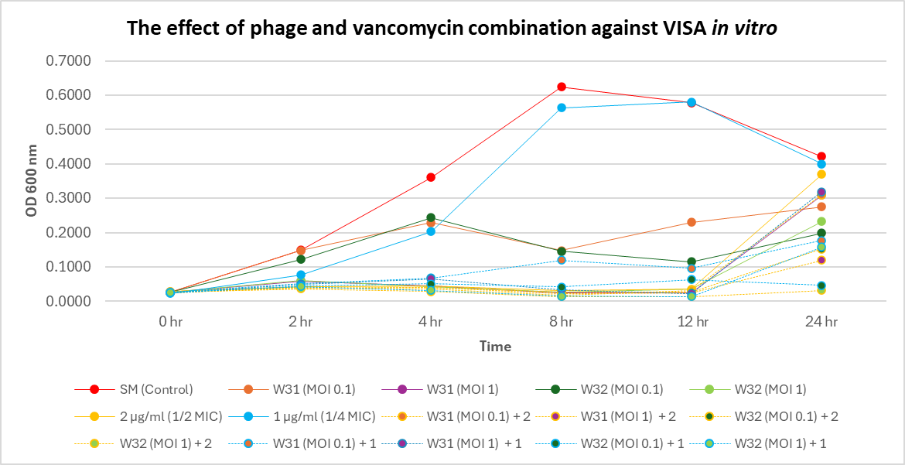
Figure 3: The effect of bacteriophage and vancomycin combination against VISA in vitro (OD 600nm)

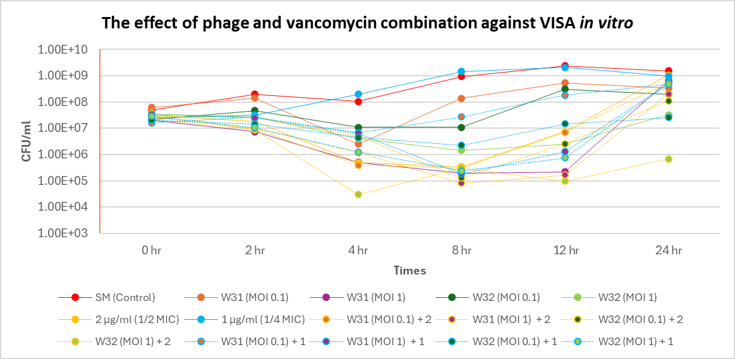
Figure 4: The effect of bacteriophage and vancomycin combination against VISA in vitro (CFU/ml)

5. Conclusion
The combination of bacteriophages W31 or W32 with vancomycin enhanced antibacterial activity against both MSSA and VISA in vitro. Phage treatment alone effectively reduced bacterial growth, particularly against MSSA. However, VISA showed reduced susceptibility and bacterial regrowth over time. The phage–vancomycin combination improved bacterial reduction compared with vancomycin alone, indicating a potential synergistic effect, although complete eradication was more evident in MSSA than in VISA.

6. References
Bamigboye, B. T., Olowe, O. A., & Taiwo, S. S. (2018). Phenotypic and molecular identification of vancomycin resistance in clinical Staphylococcus aureus isolates in Osogbo, Nigeria. European Journal of Microbiology and Immunology, 8(1), 25–30. https://doi.org/10.1556/1886.2018.00003
Diallo, K., & Dublanchet, A. (2022). Benefits of Combined Phage–Antibiotic Therapy for the Control of Antibiotic-Resistant Bacteria: A Literature Review. In Antibiotics (Vol. 11, Issue 7). MDPI. https://doi.org/10.3390/antibiotics11070839
Hiramatsu, K., Hanaki, H., Ino, T., Yabuta, K., Oguri, T., & Tenover, F. C. (1997). Methicillin-resistant Staphylococcus aureus clinical strain with reduced vancomycin susceptibility. In Journal of Antimicrobial Chemotherapy (Vol. 40).
Joo, H., Wu, S. M., Soni, I., Wang-Crocker, C., Matern, T., Beck, J. P., & Loc-Carrillo, C. (2023). Phage and Antibiotic Combinations Reduce Staphylococcus aureus in Static and Dynamic Biofilms Grown on an Implant Material. Viruses, 15(2). https://doi.org/10.3390/v15020460
Kim, M., Jo, Y., Hwang, Y. J., Hong, H. W., Hong, S. S., Park, K., & Myung, H. (2018). Phageantibiotic synergy via delayed lysis. Applied and Environmental Microbiology, 84(22). https://doi.org/10.1128/AEM.02085-18
Kunisch, F., & Moreno, M. G. (2023). Bacteriophage Liquid Propagation in Pseudomonas aeruginosa. https://doi.org/10.21203/rs.3.pex-1886/v1
McCallin, S., Menzi, C., Lassen, S., Daraspe, J., Oechslin, F., & Moreillon, P. (2022). Antibiotic Exposure Leads to Reduced Phage Susceptibility in Vancomycin Intermediate Staphylococcus aureus (VISA). Antimicrobial Agents and Chemotherapy, 66(7). https://doi.org/10.1128/aac.02247-21
Peng, Q., Tang, X., Dong, W., Sun, N., & Yuan, W. (2023). A Review of Biofilm Formation of Staphylococcus aureus and Its Regulation Mechanism. In Antibiotics (Vol. 12, Issue 1). MDPI. https://doi.org/10.3390/antibiotics12010012
Pires, D. P., Oliveira, H., Melo, L. D. R., Sillankorva, S., & Azeredo, J. (2016). Bacteriophage-encoded depolymerases: their diversity and biotechnological applications. In Applied Microbiology and Biotechnology (Vol. 100, Issue 5, pp. 2141–2151). Springer Verlag. https://doi.org/10.1007/s00253-015-7247-0
Shariati, A., Dadashi, M., Moghadam, M. T., van Belkum, A., Yaslianifard, S., & Darban-Sarokhalil, D. (2020). Global prevalence and distribution of vancomycin resistant, vancomycin intermediate and heterogeneously vancomycin intermediate Staphylococcus aureus clinical isolates: a systematic review and meta-analysis. Scientific Reports, 10(1). https://doi.org/10.1038/s41598-020-69058-z
Taha, M., Arnaud, T., Lightly, T. J., Peters, D., Wang, L., Chen, W., Cook, B. W. M., Theriault, S. S., & Abdelbary, H. (2023). Combining bacteriophage and vancomycin is efficacious against MRSA biofilm-like aggregates formed in synovial fluid. Frontiers in Medicine, 10. https://doi.org/10.3389/fmed.2023.1134912
Yordpratum, U., Tattawasart, U., Wongratanacheewin, S., & Sermswan, R. W. (2011). Novel lytic bacteriophages from soil that lyse Burkholderia pseudomallei. In FEMS Microbiology Letters (Vol. 314, Issue 1, pp. 81–88). https://doi.org/10.1111/j.1574-6968.2010.02150.x

