Description:
There are many type of air conditioning system used such as air-cooled split type, air-cooled compact, water-cooled chiller system. The performance of each system is much depended on its type and operation. The type of the system must be selected for specific design usage and operation. However, in many cases, the operation is far different from that of the design values. The performance, therefore, depended on each operation.
This experiment is to measure the performance of the special (non-industrial) configuration of air conditioner which comprised of water-cooled evaporator and air-cooled condenser. The system is assumed to work in air heating mode, so called heat pump, and water cooling mode, so called refrigerator or chiller. The coefficient of performance (COP) is compared among actual operation and ideal (reversible) theory.
Objectives:
1. To measure the performance of air-conditioning system for both heating and cooling modes
2. To evaluate the time to steady state effect
3. To compare the actual coefficient of performance of the apparatus against that of ideal cycle.
Theory:
Vapor Compression Refrigeration Cycle
The vapor compression refrigeration cycle is a common method for transferring heat from a low temperature to a high temperature as schematically shown in the following figure.
Figure 1 Schematic of refrigeration cycle
Coefficient of Performance (COP)
The performance of refrigerators and heat pumps is expressed in term of the coefficient
of performance (COP)
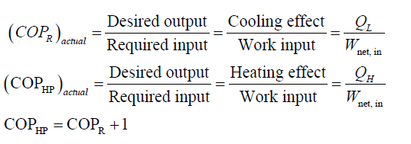

The reverse Carnot cycle coefficient of performance can be evaluated as
Figure 2 Reverse Carnot cycle

If the Carnot device is caused to operate in the reversed cycle, the reversible heat pump is
created. The COP of reversible refrigerators and heat pumps are given in a similar manner to
that of the Carnot heat engine as
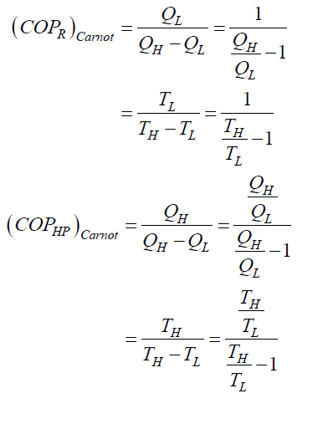
These are the maximum possible COPs for a refrigerator or a heat pump operating between the
temperature limits of TH and TL.
The coefficient of performance may be compared with an ideal performance based upon
the temperature difference across the heat pump circuit:-

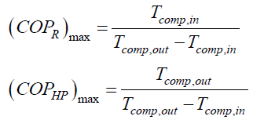
Experimental apparatus:
Figure 3 shows a general view of the apparatus which is based on the Vesatemp high
level Air condition type VH 215. This type of machines are widely used for the air conditioning
of individual rooms but the specific feature of the Versatemp is that it requires a supply of
circulating water that may be used either as the source of heat when the machine is acting as a
heat pump, or as the sink when air cooling is taking place.
Figure 3 General view of the experimental apparatus

In order to simplify the experimental technique, the air conditioner is modified in an
important respect when compared with the normal commercial – version : the duplex low speed
fan that normally circulates air, through the conditioner is replaced by a single high speed fan
delivering air to a small circular duct. The purpose of this modification is to develop a
sufficiently high velocity head to ensure that air flow may be measured by a simple pitot tube
and manometer, but the greatly increases the level of the conditioner and also results in some
reduction is efficiency. This in no way affects the performance, and in particular the noise lever,
is interior to that to be expected in normal practice. The fan in the normal unit is inaudible.
The air conditioner is completely self contained and consists of a hermetically sealed
refrigeration system driven by a l hp motor, a reversing valve, fan and motor, condensate
collector and electrical controls.
The air to be conditioned enters by the finned refrigerant to – air heat exchanger, passes
through the centrifugal fan which is driven by a motor immersed in the air flow, and is
discharged to a duct of circular cross-section carrying a pitot tube and mercury- in – glass
thermometer. When the air in being cooled and the relative humidity is high enough, moisture is
deposited or the heat exchanger and drained off to a measuring vessel.

The refrigerant- to water heat exchanger is a co-axial wire wound unit and is thermally insulated
externally.
Two separate units are associated with the air conditioner. The first consists of and
electrical control panel carrying an isolator and warning light, fuses, the necessary control and change over switches, and wattmeter. It is connected by flexible cable to the air conditioner and to the second independent unit.
The latter carries a flow meter for measurement of the quantity of water passing through the conditioner. Thermometers for water inlet and outlet temperatures, an inclined manometer
for use with the pitot-static tube for air flow measurement and a vessel containing a 2 kW
immersion heater is sometimes necessary when the conditioner is operating as a heat pump
extracting heat from the circulating water since if the temperature of the latter on entry to the
conditioner falls below about 10 C. There is a likelihood of freezing taking place. This unit is
connected by flexible cable to the control panel.
The following instruments are provided:
a) Watt meter for measurement of electrical power input to refrigerator compressor and to
fan.
b) Thermometers for measurement of air inlet and outlet temperatures both dry bulb and wet
bulb.
c) Thermometers for measurement of cooling water inlet and outlet temperatures both dry
bulb and wet bulb.
d) Pitot-static tube and inclined manometer for measurement of air flow.
e) Cooling water flow meter.
f) Thermocouple at inlet and outlet to refrigerator compressor.
Calculation:
The apparatus can be used to evaluate the COP of both as heat pump and as refrigerator
by using corresponding thermal output. Referring to

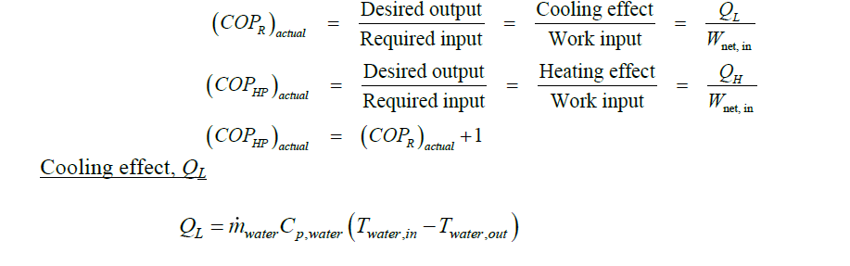
The water mass flow rate (kg/s), water m , can be calculate from the measurement of
volume flow rate as,
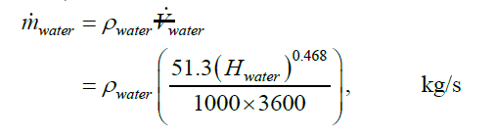
Where 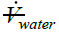 is volumetric water flow rate
Hwater is the measured circulating water flow meter head (cm.H2O.)
Heating effect, QH
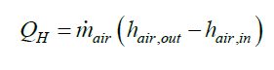

The air flow through the conditioner is measured by means of a pitot tube mounted in the
center of the discharge duct. The pressure of the air at this point is effectively equal to that of the
atmospheric, Pa, that can be obtained at the barometer in the laboratory or at
http://weather.kku.ac.th/wx200.txt (hectopascal (hPa), a unit of pressure equivalent to about
1/1000 of 1 atmosphere).
and its density is given by the gas equation:-
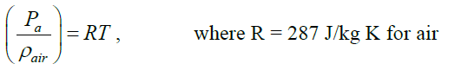
The velocity U, corresponding to a velocity head Hair (cm.H2O) as measured by the pitot tube is
given by:-
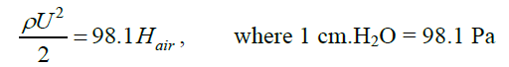
That is
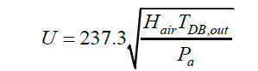
The mean velocity in the duct may be calculated by traversing the pitot tube across a horizontal
and vertical diameter and integrating to obtain the total flow. Such a calibration for the apparatus
in this experiment gives a value:-

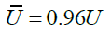

Therefore the volumetric flow rate in the duct, diameter D, is given by:-

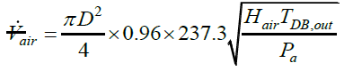

for this case, D = 0.073 m, therefore:-

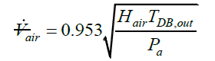

By using the gas equation to obtain the air density the air mass flow rate is then given by:-
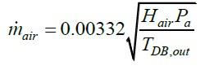
Where Hair = Pitot tube air head, cm.H2O
Pa = atmospheric pressure, Pa
TDB,out = Outlet air temperature, K
The enthalpy of air can be obtained by using either psychometric chart or Engineering
Equation Solver (EES). The independent variables are dry bulb temperature TDB and wet bulb
temperature, TWB, in Kelvin (K).

Enthalpy of moist air
Moist air is a mixture of dry air and water vapor. In atmospheric air, water vapor content
varies from 0 to 3% by mass. The enthalpy of moist and humid air includes the
• enthalpy of the dry air - the sensible heat – and
• the enthalpy of the evaporated water - the latent heat
Specific enthalpy – hair - (J/kg) of moist air is defined as the total enthalpy (J) of the dry air and the water vapor mixture - per unit mass (kg, lb) of moist air.

Specific Enthalpy of Moist Air
Specific enthalpy of moist air can be expressed as:

hair = ha + ω hw

where
hair = specific enthalpy of moist air (kJ/kg
ha = specific enthalpy of dry air (kJ/kg)
ω = humidity ratio (kg/kg)
hw = specific enthalpy of water vapor (kJ/kg)

Specific Enthalpy of Dry Air - Sensible Heat
Assuming constant pressure conditions the specific enthalpy of dry air can be expressed as:
ha = Cpa Tair
where
Cpa = specific heat capacity of air at constant pressure (kJ/kg °C)
= 1.005 (kJ/kg °C)
Tair = air temperature (°C)
Note! that the enthalpy is 0 kJ/kg at 0oC. This is not correct according the definition of enthalpy in the thermodynamics, but for practical purposes in air psychrometrics this assumption is good enough since our interest is the enthalpy difference.

Specific Enthalpy of Water Vapor - Latent Heat
Assuming constant pressure conditions the specific enthalpy of water vapor can be expressed as:
hw = Cpw Tair + hwe
where
Cpw = specific heat capacity of water vapor at constant pressure (kJ/kg °C)
= 1.887 (kJ/kg °C)
Tair = water vapor temperature at dry air temperature (°C)
hwe = evaporation heat of water at 0°C (kJ/kg)
= 2501 (kJ/kg)
There for
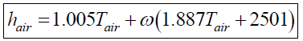
where
hair = enthalpy (kJ/kg)
ω = air humidity ratio (kg/kg)
Tair = dry air temperature (°C)
The humidity ratio of air, x, can be obtained from Engineering Equation Solver, EES using
function
omega=HumRat(AirH2O,T=T_DB_in,B=T_WB_in,P=Pa)

Net power input
The power input to the system is measure from compressor and fan using front pane
l kW meter.

Test Procedure and Operation Instructions:
Figure 4 Main control penel

1) Make sure that all switches are at OFF position
2) Turn on the cooling water and regulate to give a head, Hwater, of what given by the instructor.
3) Select “AIR CONDITIONER” switch ❷ to “HEAT”
4) Turn the main switch ❶ ON
5) Turn the fan switch ❸ and compressor switch ❹ ON
6) Start recording data using the data collection sheet every 2 minutes until the two successive readings show a change in air and water temperature of not more
than 0.3 °C.

Data analysis and reporting

1) The calculation of (COPR)actual, (COPR)carnot, and (COPR)max
2) The calculation of (COPHP)actual, (COPHP)carnot, and (COPHP)max
3) Comparison plots of COP versus Time

ผลการทดลอง

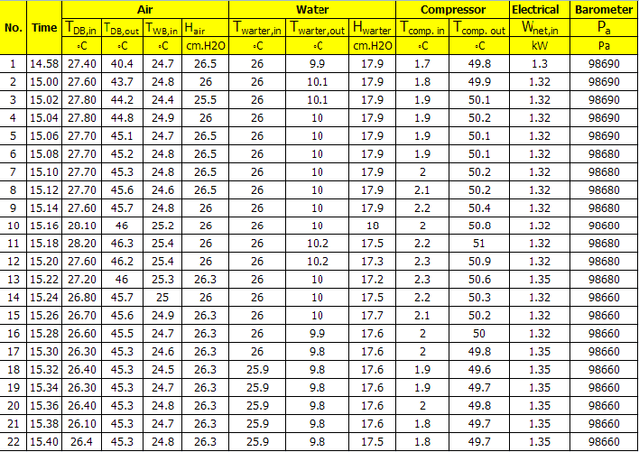

No. | Cp | Tw | rho | m water | m air | omega | h air in | h air out | Ql | QH
1 | 4.186 | 26.0 | 999.1 | 0.0549 | 0.3033 | 0.001091 | 30.32 | 43.41 | 3.702 | 3.9705
2 | 4.186 | 26.0 | 999.1 | 0.0549 | 0.2988 | 0.001132 | 30.63 | 46.84 | 3.656 | 4.8456
3 | 4.186 | 26.0 | 999.1 | 0.0549 | 0.2957 | 0.001378 | 31.46 | 47.98 | 3.656 | 4.8866
4 | 4.186 | 26.0 | 999.1 | 0.0549 | 0.2983 | 0.001173 | 30.93 | 48.06 | 3.679 | 5.1080
5 | 4.186 | 26.0 | 999.1 | 0.0549 | 0.3010 | 0.001173 | 30.83 | 48.36 | 3.679 | 5.2758
6 | 4.186 | 26.0 | 999.1 | 0.0549 | 0.3010 | 0.001173 | 30.83 | 48.46 | 3.679 | 5.3050
7 | 4.186 | 26.0 | 999.1 | 0.0549 | 0.3009 | 0.001173 | 30.83 | 48.56 | 3.679 | 5.3345
8 | 4.186 | 26.0 | 999.1 | 0.0549 | 0.3008 | 0.001255 | 31.04 | 49.07 | 3.679 | 5.4237
9 | 4.186 | 26.0 | 999.1 | 0.0549 | 0.2979 | 0.001132 | 30.63 | 48.86 | 3.679 | 5.4302
10 | 4.186 | 26.0 | 999.1 | 0.0551 | 0.2977 | 0.001173 | 31.24 | 49.27 | 3.688 | 5.3681
11 | 4.186 | 26.0 | 999.1 | 0.0543 | 0.2976 | 0.001131 | 31.23 | 49.46 | 3.594 | 5.4251
12 | 4.186 | 26.0 | 999.1 | 0.0541 | 0.2977 | 0.000885 | 30.00 | 48.72 | 3.575 | 5.5732
13 | 4.186 | 26.0 | 999.1 | 0.0539 | 0.2995 | 0.000762 | 29.28 | 48.20 | 3.611 | 5.6660
14 | 4.186 | 26.0 | 999.1 | 0.0543 | 0.2979 | 0.000720 | 28.77 | 47.79 | 3.640 | 5.6652
15 | 4.186 | 26.0 | 999.1 | 0.0546 | 0.2996 | 0.000721 | 28.67 | 47.69 | 3.659 | 5.6987
16 | 4.186 | 26.0 | 999.1 | 0.0545 | 0.2997 | 0.000762 | 28.68 | 47.70 | 3.672 | 5.7001
17 | 4.186 | 26.0 | 999.1 | 0.0545 | 0.2998 | 0.000680 | 28.17 | 47.29 | 3.695 | 5.7312
18 | 4.186 | 25.9 | 999.1 | 0.0545 | 0.2998 | 0.000762 | 28.48 | 47.50 | 3.672 | 5.7019
19 | 4.186 | 25.9 | 999.1 | 0.0545 | 0.2998 | 0.000639 | 28.06 | 47.18 | 3.672 | 5.7307
20 | 4.186 | 25.9 | 999.1 | 0.0545 | 0.2998 | 0.000639 | 28.16 | 47.18 | 3.672 | 5.7005
21 | 4.186 | 25.9 | 999.1 | 0.0545 | 0.2998 | 0.000557 | 27.65 | 46.97 | 3.672 | 5.7901
22 | 4.186 | 25.9 | 999.1 | 0.0543 | 0.2998 | 0.000226 | 27.11 | 46.11 | 3.663 | 5.6961

NO. | Coefficent of Performance
NO. | COPR |  |  | COPHP
NO. | Actual | Carnot | max | Actual | Carnot | max
1 | 2.847 | 13.763 | 0.035 | 3.054 | 14.763 | 1.035
2 | 2.769 | 3.072 | 0.037 | 3.671 | 4.072 | 1.037
3 | 2.769 | 2.969 | 0.039 | 3.702 | 3.969 | 1.039
4 | 2.787 | 2.573 | 0.039 | 3.870 | 3.573 | 1.039
5 | 2.787 | 2.303 | 0.039 | 3.997 | 3.303 | 1.039
6 | 2.787 | 2.262 | 0.039 | 4.019 | 3.262 | 1.039
7 | 2.787 | 2.221 | 0.041 | 4.041 | 3.221 | 1.041
8 | 2.787 | 2.108 | 0.044 | 4.109 | 3.108 | 1.044
9 | 2.787 | 2.100 | 0.046 | 4.114 | 3.100 | 1.046
10 | 2.794 | 2.195 | 0.041 | 4.067 | 3.195 | 1.041
11 | 2.723 | 1.963 | 0.045 | 4.110 | 2.963 | 1.045
12 | 2.708 | 1.789 | 0.047 | 4.222 | 2.789 | 1.047
13 | 2.674 | 1.757 | 0.048 | 4.197 | 2.757 | 1.048
14 | 2.757 | 1.797 | 0.046 | 4.292 | 2.797 | 1.046
15 | 2.772 | 1.794 | 0.044 | 4.317 | 2.794 | 1.044
16 | 2.782 | 1.811 | 0.042 | 4.318 | 2.811 | 1.042
17 | 2.737 | 1.815 | 0.042 | 4.245 | 2.815 | 1.042
18 | 2.720 | 1.810 | 0.040 | 4.224 | 2.810 | 1.040
19 | 2.720 | 1.784 | 0.040 | 4.245 | 2.784 | 1.040
20 | 2.720 | 1.811 | 0.042 | 4.223 | 2.811 | 1.042
21 | 2.720 | 1.734 | 0.038 | 4.289 | 2.734 | 1.038
22 | 2.713 | 1.801 | 0.038 | 4.219 | 2.801 | 1.038

